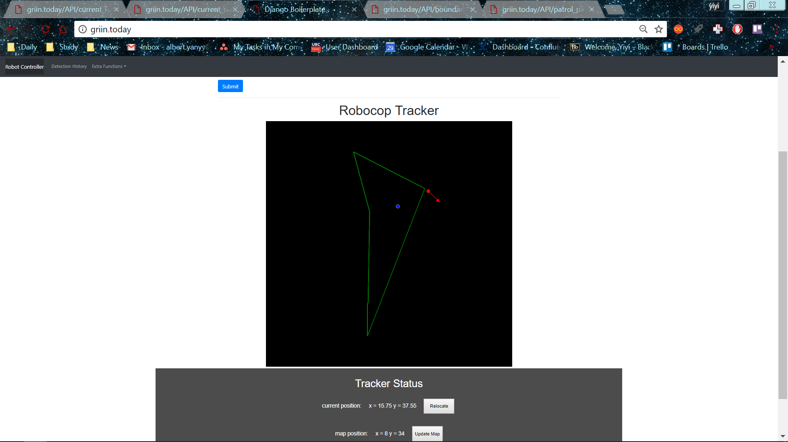

{"boundaries": [{"x": 0.0, "y": 0.0}, {"x": 0.0, "y": 0.0}, {"x": 0.0, "y": 0.0}, {"x": 0.0, "y": 8.32}, {"x": 0.18, "y": 8.72}, {"x": 0.5700000000000001, "y": 32.24}, {"x": -3.63, "y": 47.75}, {"x": 14.16, "y": 38.58}, {"x": 14.81, "y": 38.25}]}

Problem: the pattern was going straight, and make a perfect 90 degree turn. The top most point is the correct, since we did move about 50m (47.75).

Solution: fix the 90 degree turns for now

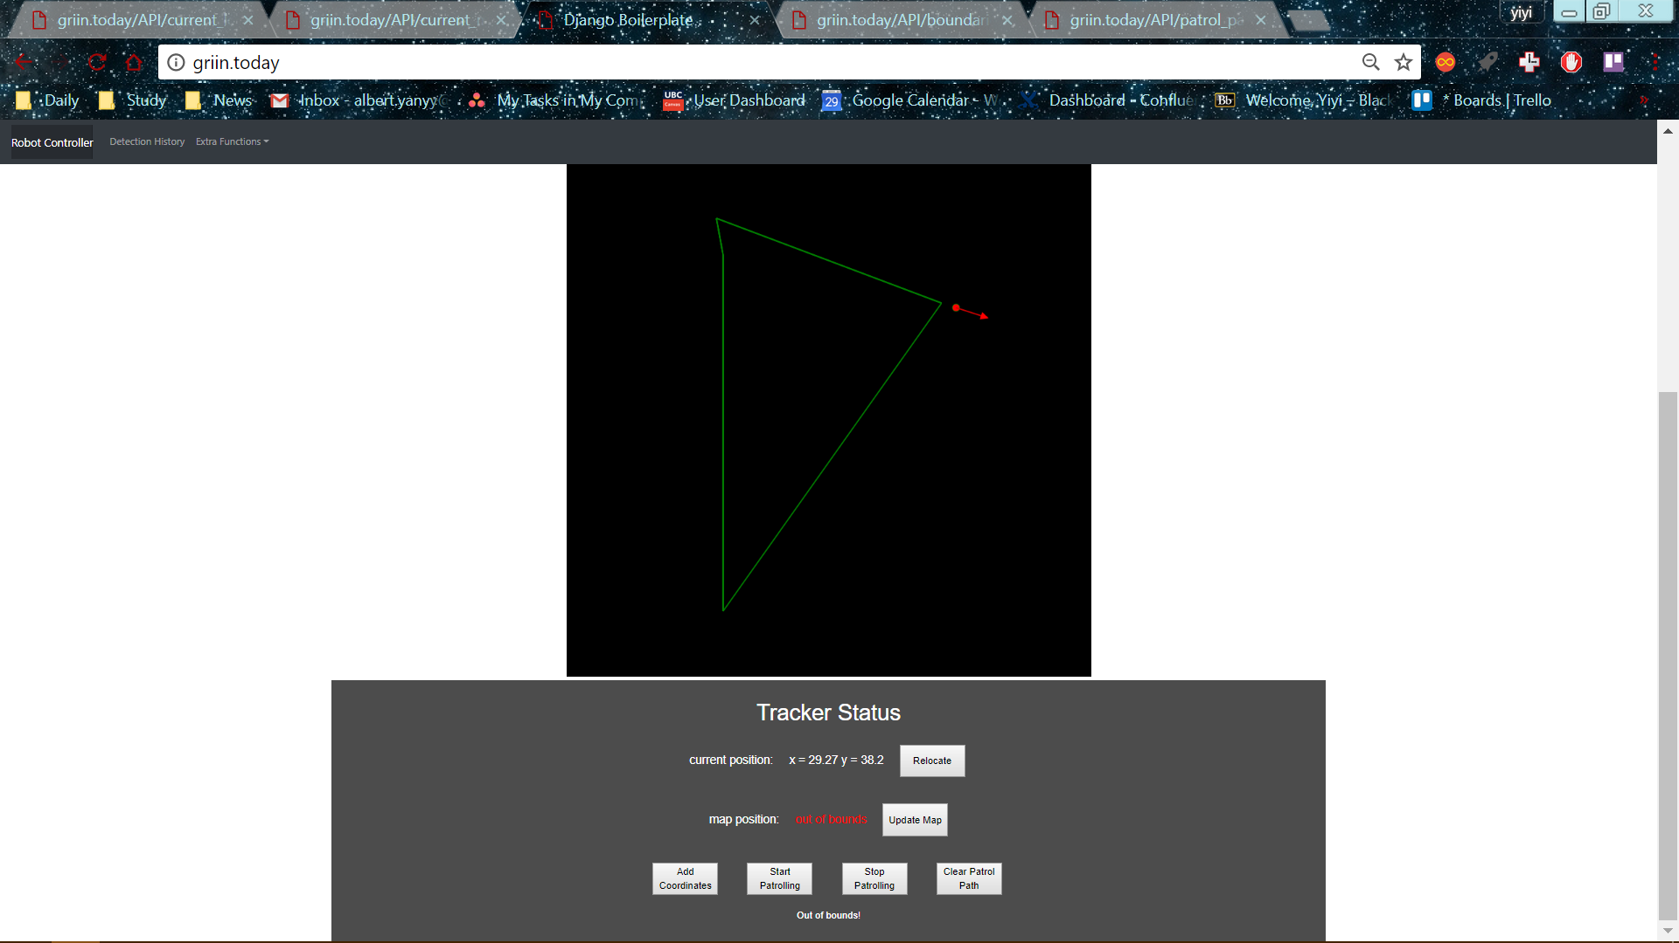

{"boundaries": [{"x": 0.0, "y": 0.0}, {"x": 0.0, "y": 44.85}, {"x": -0.84, "y": 49.45}, {"x": 27.46, "y": 38.78}]}